Moon Zoom Home learning
Welcome back everyone! We hope you all had an amazing 6 week holidays and have come back to school refreshed and eager to learn. This half term is an exciting one with a focus on Space and materials! Below are 6 different homework tasks for you and your child to complete together. If you return 5 of the homework then your child will take part in a homework treat. This half term it is going to be a picnic and games outside.
Challenge 1:  With an adult, search the web or books for as many amazing space facts as you can find and create your own fact book to share with all the key stage 1 classes. | Challenge 2:  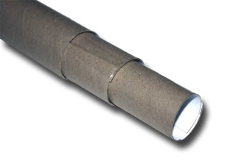  Make a telescope from junk cardboard materials and sticky tape. Use your telescope to look at the night stars. Draw pictures of what you have seen. | Challenge 3:  Can you make your own space song or rhyme? Teach it to the class so we can make a space choir!
Challenge 4:  Can you make an alien mask? Use different materials that you ca fin around the house. We can’t wait to see them! We can have an alien parade as part of the picnic treat.  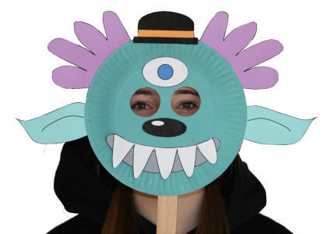 | Challenge 5:  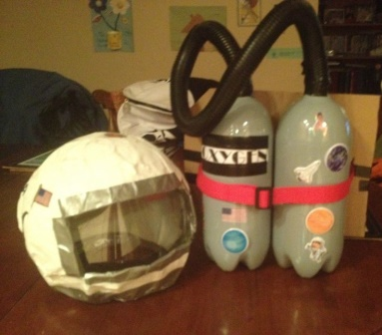  Make an astronauts helmet so you can explore space! | Challenge 6:  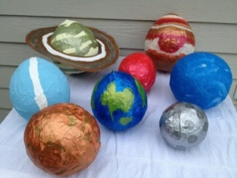  Can you use paper mache to make your own solar system and planets? We can hang these from the ceiling to make it seem like we are in deep space!

